02 January 2025

The below and attached are samples of varied work by Michael S. Balensiefer:

1. In a CBP technical position, a Developer lead issued the following brainstorm:

|  |
| --- |
| Naray is an awesome developer on the TRG team. He is always willing to share his knowledge with the team. He always offers help not only in development tasks but also in system admin tasks. The TRG team appreciates all the excellent work Naray has done. Naray has helped on many complex projects. Couple of such:  The technical integration between SailPoint and TRG to automate the TRG User Access process, and the Integration between Outlook and the TRG Reservation system.  Naray worked on backend Integration Triggers in SailPoint Integration Project. SailPoint integration was needed due to huge volume of users migrating to TRG. By automating the User Access process via SailPoint we had:  Integration between Outlook and TRG Reservation project was a high visibility project. Ashburn was in the process of connecting Cisco Room Kits into Microsoft Teams. Naray took over when the developer who started the work had to leave. He caught up with the requirements quickly and delivered this initiative successfully on time. |

Which I used to compose and submit the following award nomination:

|  |
| --- |
| Team TRIRIGA is proud to nominate Naray Rama for the SGI "Customer’s Champion" award. Developer Naray Rama contributed SME level effort to two critical projects:   1. Naray spearheaded the technical integration between Identity and Access Management (IAM) tool *SailPoint* and CBP’s *TRG* software to automate a traditionally manual User Access process that significantly reduced the amount of time it takes for users to obtain access and increased the accuracy of the user dataset to enable thousands of new users to join under an automated process that vastly expanded the visibility of TRG within CBP. 2. Under similar diligence, Mr. Rama assumed the work of a departing Developer to steward the technical integration between the Outlook email client and TRIRIGA’s *Reservation* system to deliver this high-profile initiative successfully and on time.   Naray's professional knowledge, naturally selfless contributions, and programming strengths are a motivating force to the Team and make him a true “Customer’s Champion”; Naray is a deserving candidate for this award as his work has a significant impact on TRG’s users, the CBP and SGI. |

1. The below is a digital advertisement that I created:



1. The below are printscreens of a presentation that I produced and spoke to for a Malware case study. The audience is the general public:

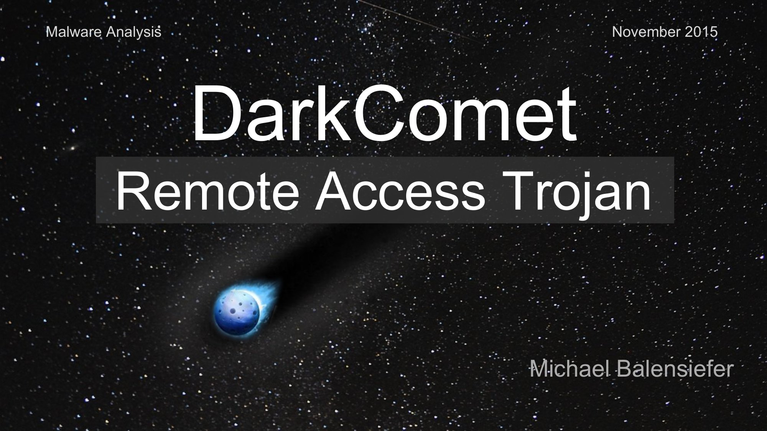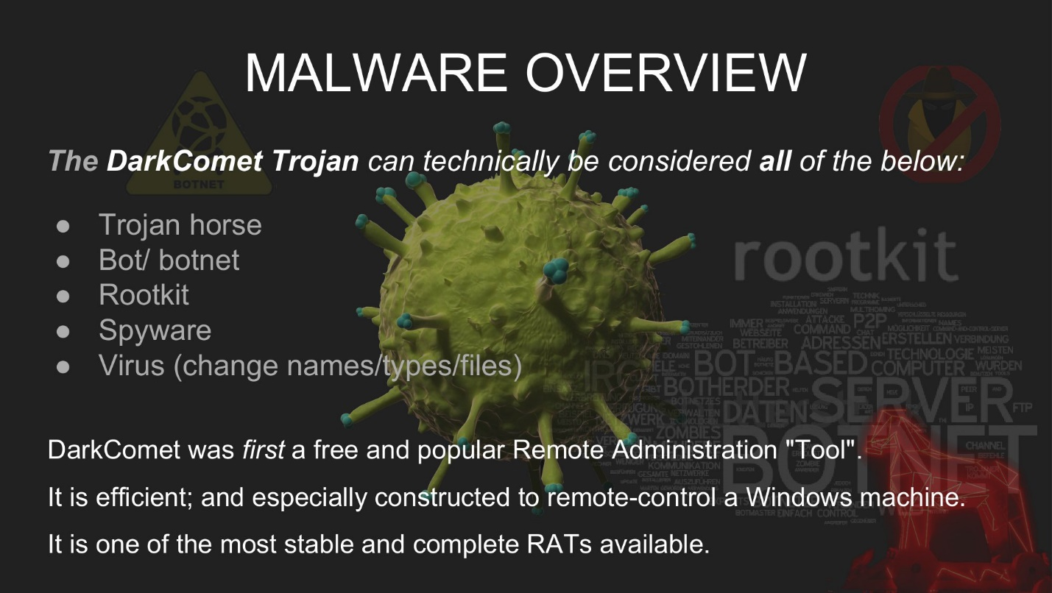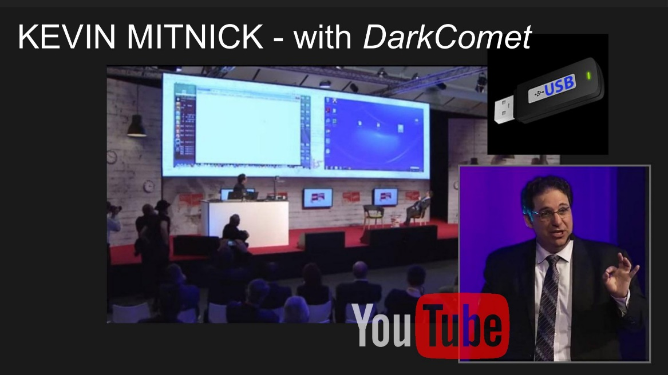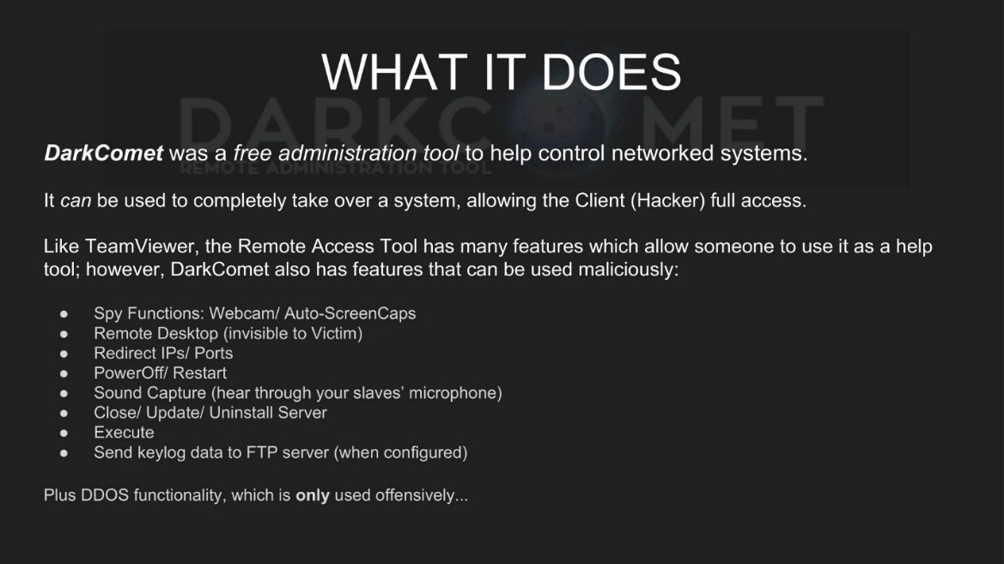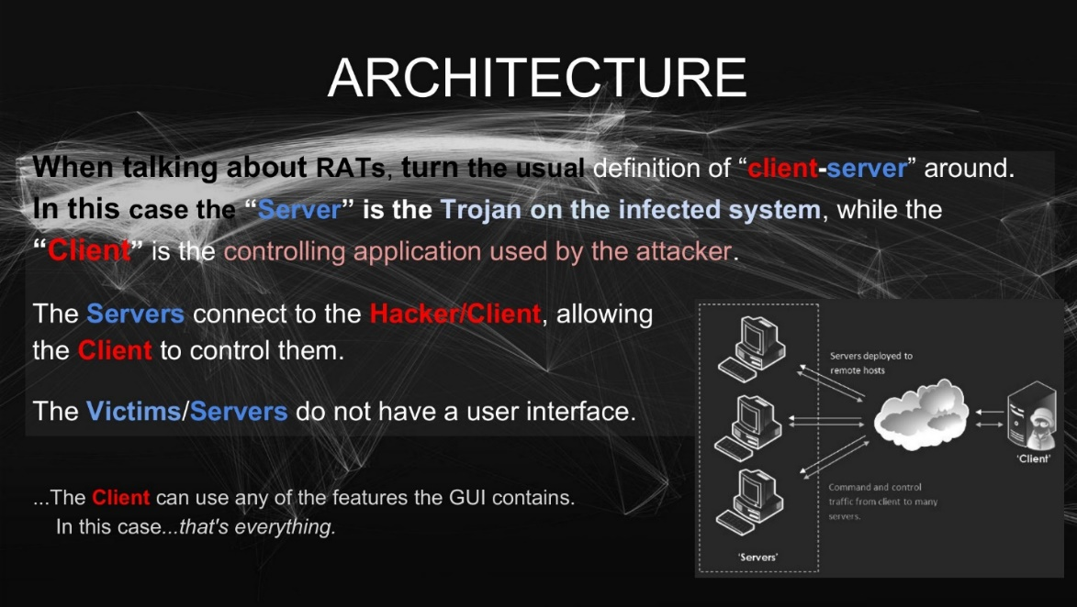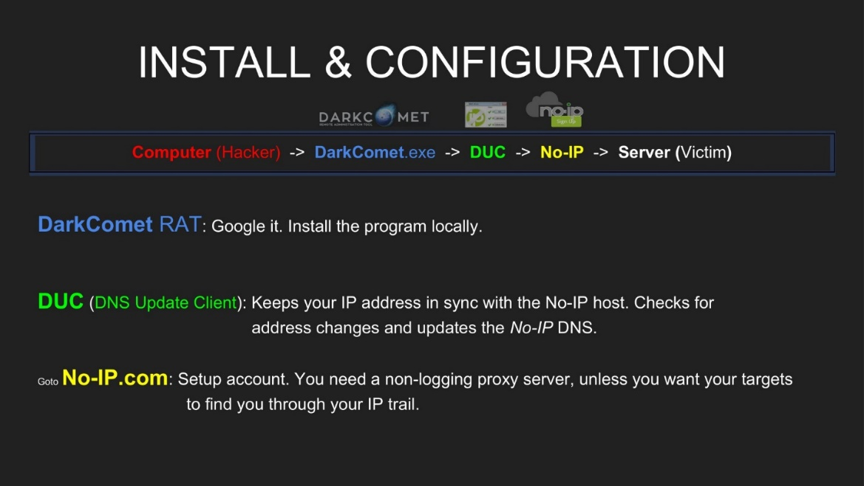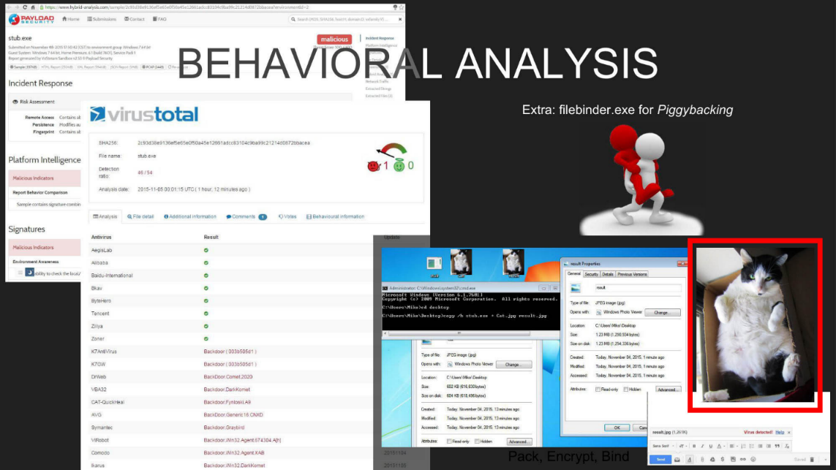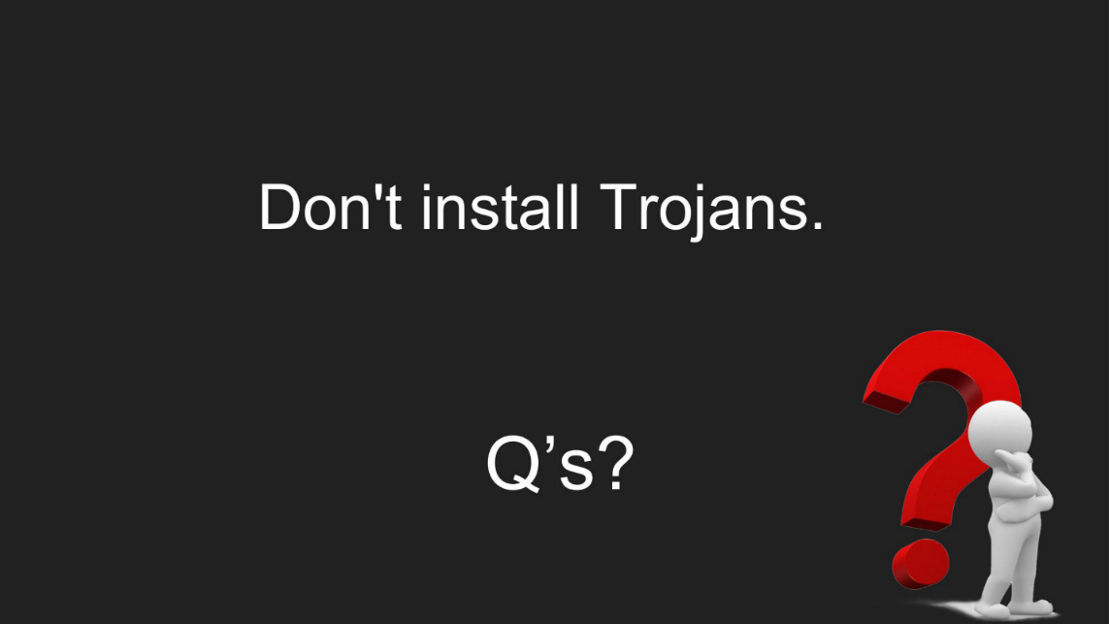

1. The below is a basic System Diagram:

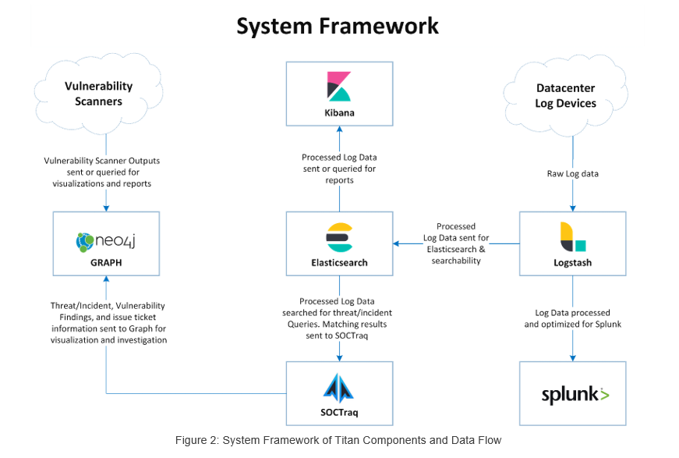

1. Attached is a Sales Whitesheet for an obsolete product:



1. Attached is a Technical Whitesheet that describes the installation, setup, and customization of **faux** software:



~END~